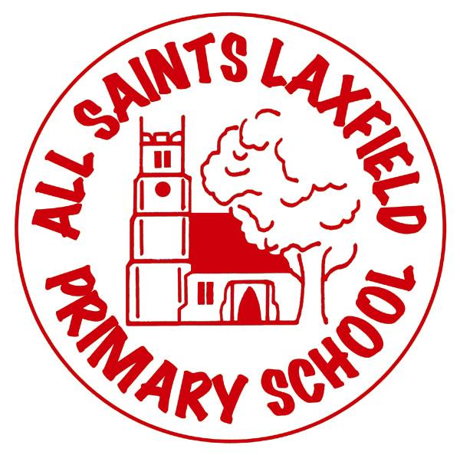
All Saints Science Curriculum
A family. Uniquely made and loved by God
Intent
At All Saints Laxfield, we believe that science answers some of the big questions in life. It encompasses the disciplines of biology, chemistry and physics through theoretical understanding and practical application. Science is all around us and engaging with it allows children to understand much of how the world works. We want our children to be excited by science, to be curious, to question and to challenge. We want them to recognise that our society’s understanding of science is not fixed; it is forever changing, developing and progressing and they are a part of that.

Key concepts:
Plants, animals including humans, materials, seasonal changes, living things and their habitats, rocks and soils, sound, light, forces and magnets, states of matter, electricity, Earth and space, evolution and inheritance.

Our locality
Our rural location gives us access to a wonderful village, fenland and the East coast. Our grounds provide hedgerows, trees, a small forest area and plenty of space for investigations, experiments, data collection and observations.

Implementation Making science come alive.
Working scientifically through observing over time; pattern seeking; identifying, classifying and grouping; comparative and fair testing is vital in order to help children see science ‘happening’ in front of them. Our curriculum is based on a sequence of knowledge and concepts which enable effective scientific investigations to occur. Technical vocabulary (through the use of knowledge organisers) is embedded into lessons to ensure precise scientific explanations and writing, where appropriate, can be produced. Science is often linked to maths, English, P.E, art, D.T and R.E in order to deepen understanding and enhance enjoyment of this core subject.

Impact Assessment
Assessment is continuous and evidenced through the use of our marking policy. Assessment may also be more formal such as a task at the start and end of a topic, mini quizzes or a final piece of writing. Scientific skills as well as factual knowledge will be assessed in order to decide whether a child is working towards, at expected or working above the expected standard.

