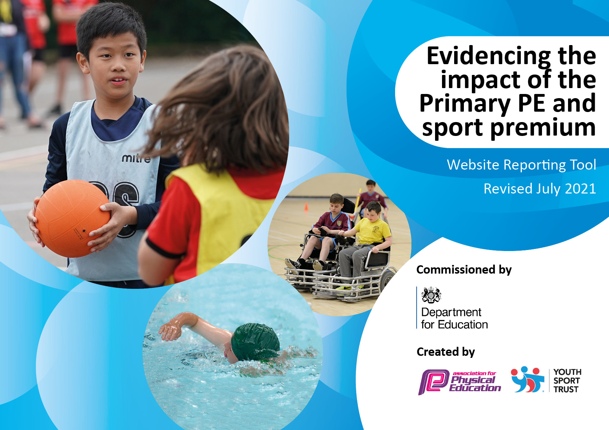
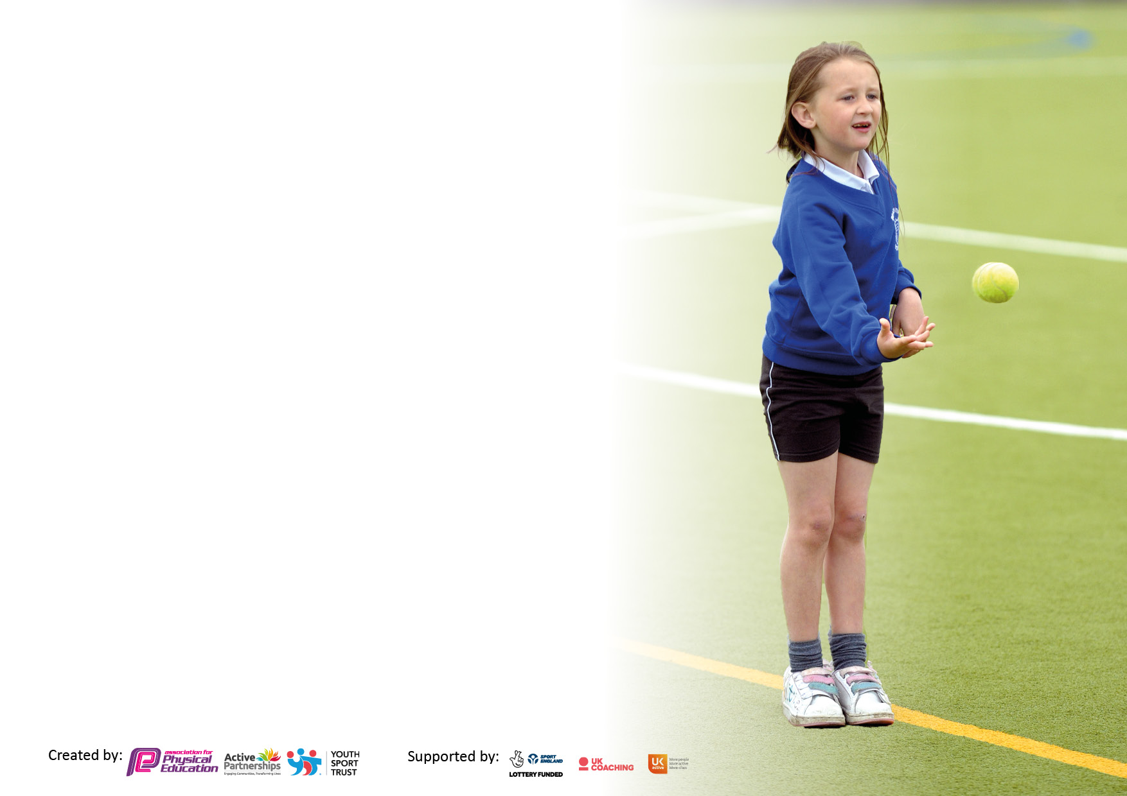

It is important that your grant is used effectively and based on school need. The Education Inspection Framework makes clear there will be a focus on ‘whether leaders and those responsible for governors all understand their respective roles and perform these in a way that enhances the effectiveness of the school’.

Under the Quality of Education Ofsted inspectors consider:
Intent - Curriculum design, coverage and appropriateness
Implementation - Curriculum delivery, Teaching (pedagogy) and Assessment
Impact - Attainment and progress

To assist schools with common transferable language this template has been developed to utilise the same three headings which should make your plans easily transferable between working documents.

Schools must use the funding to make additional and sustainable improvements to the quality of Physical Education, School Sport and Physical Activity (PESSPA) they offer. This means that you should use the Primary PE and sport premium to:

- Develop or add to the PESSPA activities that your school already offer
- Build capacity and capability within the school to ensure that improvements made now will benefit pupils joining the school in future years
- The Primary PE and sport premium should not be used to fund capital spend projects; the school’s budget should fund these.

Pleasevisitgov.ukfortherevisedDfEguidanceincludingthe5keyindicatorsacrosswhichschoolsshoulddemonstrate animprovement.Thisdocumentwillhelpyoutoreviewyourprovisionandtoreportyourspend.DfEencouragesschools to use this template as an effective way of meeting the reporting requirements of the Primary PE and sport premium.

We recommend you start by reflecting on the impact of current provision and reviewing the previous spend.

Schools are required to publish details of how they spend this funding, including any under-spend from 2019/2020, as well as on the impact it has on pupils’ PE and sport participation and attainment. All funding must be spent by 31st July 2022.

We recommend regularly updating the table and publishing it on your website throughout the year. This evidences your ongoing self-evaluation of how you are using the funding to secure maximum, sustainable impact. Final copy must be posted on your website by the end of the academic year and no later than the 31st July 2021. To see an example of how to complete the table please click HERE.

Details with regard to funding
Please complete the table below.

Total amount carried over from 2019/20 | £0
Total amount allocated for 2020/21 | £16960
How much (if any) do you intend to carry over from this total fund into 2021/22? | £2540
Total amount allocated for 2021/22 | £
Total amount of funding for 2021/22. To be spent and reported on by 31st July 2022. | £
Swimming Data
Please report on your Swimming Data below.

Meeting national curriculum requirements for swimming and water safety.  N.B. Complete this section to your best ability. For example you might have practised safe self-rescue techniques on dry land which you can then transfer to the pool when school swimming restarts.  Due to exceptional circumstances priority should be given to ensuring that pupils can perform safe self rescue even if they do not fully meet the first two requirements of the NC programme of study | N/A due to Covid-19 pandemic.
What percentage of your current Year 6 cohort swim competently, confidently and proficiently over a distance of at least 25 metres?  N.B. Even though your pupils may swim in another year please report on their attainment on leaving primary school at the end of the summer term 2020.  Please see note above | N/A due to Covid-19 pandemic.
What percentage of your current Year 6 cohort use a range of strokes effectively [for example, front crawl, backstroke and breaststroke]?  Please see note above | N/A due to Covid-19 pandemic.
What percentage of your current Year 6 cohort perform safe self-rescue in different water-based situations? | N/A due to Covid-19 pandemic.
Schools can choose to use the Primary PE and sport premium to provide additional provision for swimming but this must be for activity over and above the national curriculum requirements. Have you used it in this way? | No

Action Plan and Budget Tracking
Capture your intended annual spend against the 5 key indicators. Clarify the success criteria and evidence of impact that you intend to measure to evaluate for pupils today and for the future.

Academic Year: 2020/21 | Total fund allocated: | Date Updated:
Key indicator 1: The engagement of all pupils in regular physical activity – Chief Medical Officers guidelines recommend that primary school pupils undertake at least 30 minutes of physical activity a day in school |  |  |  | Percentage of total allocation:
 |  |  |  | %
Intent | Implementation |  | Impact
Your school focus should be clear what you want the pupils to know and be able to do and about  what they need to learn and to  consolidate through practice: | Make sure your actions to achieve are linked to your intentions: | Funding allocated: | Evidence of impact: what do pupils now know and what can they now do? What has changed?: | Sustainability and suggested next steps:
Increase activity for pupils outside of PE lessons.  Ensure 2 hours quality PE taught to all children every week. | See below | See below | See below  Children very engaged and active during PE. Many report enjoying PE or saying it is their favourite subject. | Investigate other sports and activities which could be introduced through after school clubs and within the curriculum.
Key indicator 2: The profile of PESSPA being raised across the school as a tool for whole school improvement |  |  |  | Percentage of total allocation:
 |  |  |  | 43%
Intent | Implementation |  | Impact
Your school focus should be clear what you want the pupils to know and be able to do and about  what they need to learn and to  consolidate through practice: | Make sure your actions to achieve are linked to your intentions: | Funding allocated: | Evidence of impact: what do pupils now know and what can they now do? What has changed?: | Sustainability and suggested next steps:
Improve provision of physical activities/play at breakfast club, lunch, early mornings and break times to link to healthy active lifestyles and positive behaviour.  Provision for children after school through the creation of ‘The Club’.  Provision for children to be active outdoors through the use of gardening.  Links to healthy eating and healthy lifestyles work in science and whole school day.  Wider range of sports and activities to be planned and taught across the school. | Grounds work/maintenance including field markings and climbing equipment to ensure greatest use of outdoor areas throughout year.  Review and maintain play/ lunchtime play resources.  Teaching assistant to run the club daily from 3.15-5.00pm. Part of this time to be spent outdoors (weather permitting) and for children to engage in physical activity of their own choice and gardening.  TA time plus equipment/ seeds etc  Whole school curriculum to be reviewed and taught by specialist. | £1000  £3000  £2000  £200 | Children using equipment daily.  Child feedback regarding use of climbing frames/ ropes/ tyres etc. Observed use of new play equipment. Equipment boxes usually emptied during break as all pieces of equipment being used.  The club is popular with parents and children. At least 30 minutes is spent outside every session or if too wet, physical activities such as dodge ball take place in the hall. If weather is good, much of the time is spent outdoors with children using a variety of climbing/ sports equipment. Gardening has been very popular with students.  Pupils have had the chance to maintain the school garden. Pupils have had the chance to eat fruit and vegetables grown in the school garden.  Whole school curriculum is developing and broadening. | Maintain amount and variety of play equipment  The club will continue next year and provide a greater range of activities.  Gardening will continue during growing periods.  PE lead to attend CPD and carry out research into new activities and sports that can be embedded in curriculum.

Key indicator 3: Increased confidence, knowledge and skills of all staff in teaching PE and sport |  |  |  | Percentage of total allocation:
 |  |  |  | 40%
Intent | Implementation |  | Impact
Your school focus should be clear | Make sure your actions to | Funding | Evidence of impact: what do | Sustainability and suggested
what you want the pupils to know | achieve are linked to your | allocated: | pupils now know and what | next steps:
and be able to do and about | intentions: |  | can they now do? What has
what they need to learn and to |  |  | changed?:
consolidate through practice:
Upskill PE co-ordinator and teachers in key areas.  Staff able to observe/work with PE specialist to improve own teaching of PE. | Sign up to the schools partnership.  PE specialist to teach across all key stages and to upskill staff through observations, CPD and resources. | £520 sign up  £200 for supply teacher cover.  £5000 | Activities from course used in school.  More staff engaged with teaching PE. Broader range of team games being taught. | PE co-coordinator to share notes/ ideas from courses with rest of staff.
Key indicator 4: Broader experience of a range of sports and activities offered to all pupils |  |  |  | Percentage of total allocation:
 |  |  |  | 17%
Intent | Implementation |  | Impact
Your school focus should be clear | Make sure your actions to | Funding | Evidence of impact: what do | Sustainability and suggested
what you want the pupils to know | achieve are linked to your | allocated: | pupils now know and what | next steps:
and be able to do and about | intentions: |  | can they now do? What has
what they need to learn and to |  |  | changed?:
consolidate through practice:
Plan residential trips which offer sports and activities that cannot be provided within school.  Improve & replace equipment and resources to access new/existing sports. | Introduces children to sports and activities they may not have considered before e.g canoeing and rock climbing.  Fund/ part fund disadvantaged children who would otherwise not take part in such activities.  Access to new/ existing sports.  Pupils have access to resources in lessons on a 1:1 basis increasing the engagement in lessons. | £500  £2000 | Pupils have a new found love for a range of activities that they had not previously known about.  Children in bigger classes have enough equipment. Increased engagement. | Continue to investigate residential centres for pupils to extend knowledge/ participation in activities.  Continue to maintain levels of equipment.

Key indicator 5: Increased participation in competitive sport |  |  |  | Percentage of total allocation:
 |  |  |  | 3%
Intent | Implementation |  | Impact
Your school focus should be clear | Make sure your actions to | Funding | Evidence of impact: what do | Sustainability and suggested
what you want the pupils to know | achieve are linked to your | allocated: | pupils now know and what | next steps:
and be able to do and about | intentions: |  | can they now do? What has
what they need to learn and to |  |  | changed?:
consolidate through practice:
Signed up to the schools partnership | Children to be involved in competitions with other schools | (See above) | KS2 and some KS1 children all attended a virtual cross country. In a team effort, Year 2 came 2nd, Years 3 and 4 came 1st and Year 5 and 6 came 2nd. Pupils in Year 6 competed in a virtual pentathlon ranking 1st. | Continue with school partnership and look to participate in more competitions.

