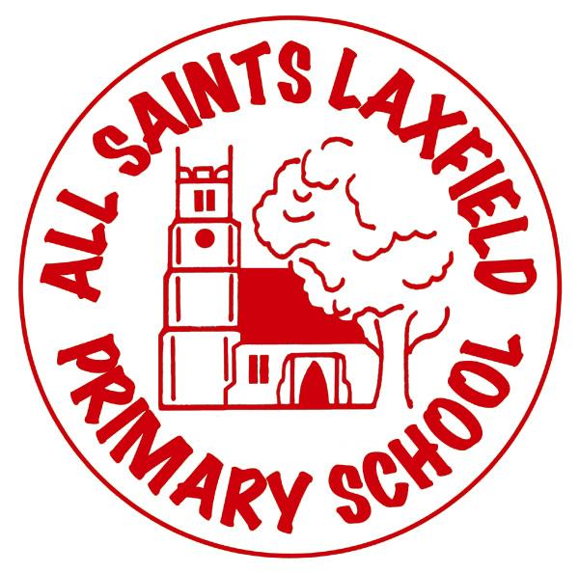
All Saints SMSC Statement
A family. Uniquely made and loved by God
Intent
At All Saints, the development of social, moral, spiritual and cultural education is a key aspect of our school and is threaded through our curriculum, school ethos and daily life. Alongside our planning, children experience enriching opportunities and everyday have the chance to explore values and beliefs and the way in which these impact people’s lives. Our school provides a happy, safe and calm environment where every child is valued as an individual.

We pride ourselves on being an inclusive school. We do our utmost ensure all children are successful learners and they are equipped with the secure foundations to lead a successful life throughout their years with us and beyond. We strive to encourage our pupils to have high expectations for themselves and to make positive contributions to not only our school community, but the wider community too. SMSC underpins everything we do and prepares our children for the opportunities, challenges and responsibilities that life offers.

Implementation

Our positive behaviour policy sets out clear expectations and encourages our children to be reflective, enables them to develop an understanding of their own and others’ feelings and emotions and understand the way in which our actions impact other people.

Through daily collective worship, we aim to provide an all-inclusive opportunity to build and reinforce our whole school values. Children are encouraged to reflect on and understand key aspects of life. Within our collective worship, we provide opportunities for spiritual, moral, social and cultural development and encourage children to share experiences and interests and celebrate special occasions as a whole school community.

We have an Ethos group of volunteers from Years 2 to 6 who are responsible for ensuring the Christian Ethos of our school is central to all that we do. We have a new group of volunteers each term and they work on a variety of activities and projects throughout the year, as well as having daily responsibilities such as welcoming everyone and saying a prayer during collective worship. Children in Key Stage 2 see additional roles and responsibilities, including the School Council, team captains and classroom monitors.

Our detailed curriculum planning provides all year groups with progressive skills coverage to ensure that relevant skills and topics are discussed and taught. Wherever possible, cross curricular links are made.

Impact

Whilst SMSC is not taught explicitly as a subject, we are confident that children have excellent opportunities throughout their school life to develop their SMSC understanding and this is evident as you look around our school and speak to our pupils.

Spiritual
- Pupils show empathy and an ability to reflect on their own and others’ achievements.
- Pupils develop their own attitudes, values and principles.
- Daily collective worship provides opportunities for celebration and expression.
- Pupils experience places of religious worship.
- Pupils have respect for themselves and others.
- Pupils have an awareness and understanding of their own and other’s beliefs.
- Pupils demonstrate imagination and creativity in their learning.

Moral
- Pupils have confidence in themselves and their community.
- Pupils can give reasons for things being right or wrong.
- The school has a positive, calm atmosphere.
- Pupils are extremely caring and take responsibility for one another. Any conflicts are resolved quickly and effectively.
- Pupils have clear values which impact on their behaviour. They understand the consequences of their behaviour and actions.
- Pupils enjoy celebrating the achievements of others and have opportunities to feel proud of themselves and others.
- Pupils are keen to engage in discussions about moral dilemmas and issues. They understand and appreciate the viewpoints of others around these issues.
- Pupils and their families are keen to engage in charity fundraising e.g. Children in Need, Comic Relief etc.

Social
- Pupils are able to socialise with a wide range of people and pupils.
- We often receive positive comments from the wider community regarding our pupils’ behaviour and manners when we go on visits/trips and when we have visitors.
- Pupils build good relationships and friendships.
- We are a very close-knit school community – all children and staff know one another well.
- Pupils feel that their opinion is valued in school.
- Pupils are given responsibilities throughout the school.
- The behaviour of pupils throughout the school is excellent due to focusing on developing social skills and an ability to work with others.
- Children quickly form good relationships with children from other schools when on residential trips or taking part in events involving other schools.
- Children who find social relationships a challenge make good progress in developing these skills through the intervention and support they receive.
- Pupils have opportunities to use technology safely.

Cultural
- Despite being a predominantly White British school, children are aware of people from different cultural backgrounds which help to contribute to a positive atmosphere in school.
- Our children are extremely inclusive and considerate of differences, for example our SEN children are popular and well cared for by their peers.
- Pupils have an understanding of the world outside of their own.
- Pupils have opportunities to showcase their talents and they feel valued for this.
- Pupils are given opportunities for awe and wonder.
- Children show willingness to participate in and respond positively to artistic, sporting and cultural opportunities.
- The school has been particularly successful in competitive events e.g. Cross Country.
- Children have the ability to to question individuals about their beliefs with enthusiasm and sensitivity.

