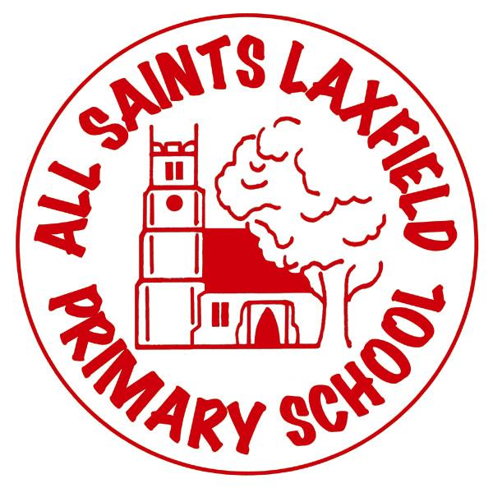
All Saints Maths Curriculum
A family. Uniquely made and loved by God
Intent
At All Saints Laxfield, we believe that mathematics equips pupils with a powerful set of tools to understand everyday life, so they are able to appreciate the world around them. These tools include logical reasoning, problem solving and the ability to think in abstract ways. Therefore, the intention for mathematics is to ensure that all pupils become fluent, reason mathematically and solve problems. Mathematics is important in everyday life. It is integral to all aspects of life and, with this in mind, we endeavour to ensure children develop a healthy and enthusiastic attitude towards mathematics that will stay with them throughout school and into their future.

Key concepts:
Number and Place Value; Addition, Subtraction, Multiplication and Division; Fractions (including decimals and percentages); Measurement; Geometry: Properties of Shape; Geometry: Position and Direction; Statistics; Ratio and Proportion; and Algebra.

Implementation Making mathematics come alive.
Mathematics links to a vast variety of subjects across the curriculum: History, Art and Geography. The close link between mathematics and science enables children to develop understanding of the real world using both their knowledge of science and mathematics, strengthening their understanding across a variety of areas. Each key concept is studied throughout the year in the order listed. All learning objectives are taught more than once and revisited throughout the year, enabling children to develop their skills and confidence to ensure a positive attitude of the subject, so real world connections can be established. Within each of the aforementioned concepts, children will develop their skills in fluency and calculation; reasoning; and problem solving. In all these areas, children will be encouraged to represent the mathematics visually so they can move through these three areas (concrete, pictorial and abstract) to ensure confidence and positive attitudes towards mathematics.

Impact Assessment
Assessment is continuous and evidenced through the use of our marking policy. Assessment may also be more formal such as a mini-assessments at the start and end of a topic, mini quizzes or formal assessment once a term. Government tests will also be used for formal assessment. Both reasoning and arithmetic knowledge will be assessed in order to decide whether a child is working towards, at expected or working above the expected standard.

