

**All Saints’ Newsletter**

**ed**

OCTOBER 2020 **Collective Worship focus: Family** www.laxfieldprimaryschool.org.uk

What we have been up to…

The artwork in our school has always been something to be proud of and this term is no exception. There are some stunning displays around the school, which reflect the skill of both staff and children. We really wanted you to see them so I hope these give you a flavour of what your child has been up to.

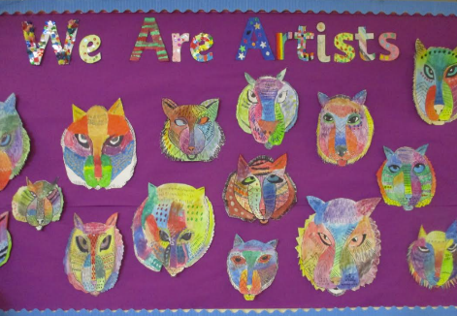



AUTUMN IS

HERE…

Now that the weather is changing and unpredictable, there will be times when the children will be outside in the rain and cold. Please could you ensure that your child has a named waterproof raincoat and water bottle with them each day.

Thank you for those that have brought in named wellington boots or walking boots. This has allowed the KS2 children use the field whatever the weather, helping us to maintain the social bubbles and give the children the space to run around.



We are hiring…

After much thought, Mrs Chambers has sadly decided to reduce the number of days she is in school. She will continue to work Mondays, Tuesdays and Wednesdays, which we are very pleased about as her experience and hard work make such a difference in Wrens class.

We have advertised a position for the remaining two days a week. Please enquire by phone or email if you would like an application form.



**All Saints’ Newsletter**

**ed**

OCTOBER 2020 **Collective Worship focus: Family** www. laxfieldprimaryschool.org.uk

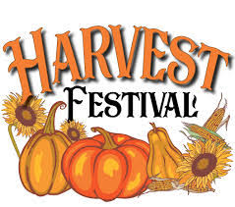

Our annual Harvest Festival is the latest casualty to the current situation. The new “rule of 6” will not allow us to have our usual church service. Each year you all give a generous offering of food for our harvest display that we donate to the local food bank. With more people than ever needing to use such a vital resource, we would still like to produce our Harvest Display within school. If you are able to spare a food item for the display please could you child bring it into school on Wednesday 14th October. We will create the display and put photos of it on our website for you all to see.

ABOUT THE FOODBANK

The foodbank is a project founded by local churches and community groups, working together towards stopping hunger in our local area.

We cover the areas in and around… Harleston, Diss, Eye, Botesdale, Banham, The Buckenhams, Long Stratton, Newton Flotman, Poringland, Brooke, Halesworth,Metfield, Beccles, Bungay, Laxfield, Stradbroke, Hoxne, Debenham, Framlingham and Wickham Market.

<https://waveney.foodbank.org.uk/>



PARENTS EVENING

A letter will be out shortly regarding parents evening and how to book your telephone call slot. These telephone calls will be for a maximum of 10 minutes each in order for teachers to talk to all parents.



**October**

**16th** Cauliflower Cards Deadline

**22nd** Stradbroke High School Assembly

**26th – 30th** Half Term

**November**

**4th** School Photo’s

**25th** Flu Immunisation

**December**

**17th** December – Last day of Term



Cauliflower Cards  
We will still be going ahead with Cauliflower cards, but this year we will be making them in class (Wrens parents, you have already had a letter about this). Please keep an eye out for your child’s work over the course of this week. Instructions on how to order the cards will be sent home too.

|  |  |  |
| --- | --- | --- |
|  |  |  |
|  |  |  |

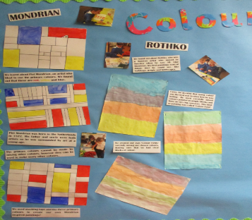

**F.O.A.L.S**

The Foals team have an up and coming AGM meeting that will take place on Thursday 15th October 2020 at 7pm.

Due to the current social guidelines, this meeting will take place via zoom. If you would like to take part in this meeting either let one of the team know or give your details to the office to pass on.



**October**

**16th** Cauliflower Cards Deadline

**22nd** Stradbroke High School Assembly

**26th – 30th** Half Term

**November**

**4th** School Photo’s

**25th** Flu Immunisation

**December**

**17th** December – Last day of Term

**Christmas is coming…**

Christmas is usually a very busy time for us at All Saints. There are many things that unfortunately we will not be able to do this year due to current restrictions; however it is such an important time of the year for us as a church school that we are determined to mark it in a special way. We will keep you updated, but if you have any brilliant ideas (we have already heard a few) please let us know.

Residentials  
Following on from Government guidance and after much consultation with insurance companies and those who run both Horstead and Hollowford residential holiday sites, the Trust has regretfully had to decide not book trips for this academic year.

We realise this will be incredibly disappointing for many children, but we must put their and staff safety first. Day trips are still allowed and so at Laxfield we will be considering what we can do instead. Any decisions will be made in light of the government guidance at the time. There are currently no plans for any class to go on a trip this term.

OCTOBER 2020 **Collective Worship focus: Family** www. laxfieldprimaryschool.org.uk

**All Saints’ Newsletter**

**ed**