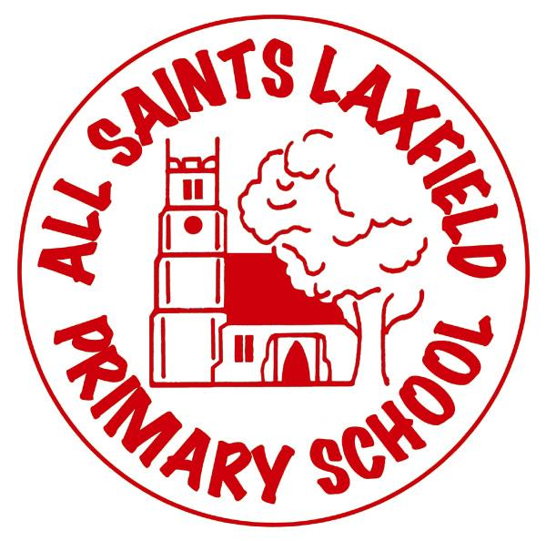
All Saints Music Curriculum
A family: uniquely made and loved by God
Intent
At All Saints we believe that music is a powerful means of communication and that it can invoke strong emotions in those who hear or play it. Music is a vital aspect of cultural influences such as religion, locality, film, sport and advertising. It is a language that can cross physical and perceived boundaries in order to bring people together and has links with science, art, dance, drama and maths. We want our children to be curious about music, to know about modern and past composers and to see themselves as musicians through the act of singing or playing an instrument.

Key concepts
analyzing, dynamics, harmony, melody pitch, rhythm, structure, tempo, texture, timbre, composing, performing, notation.

Implementation Making music come alive.
In order to develop staff confidence and knowledge of music, we are currently using Charanga and Bring the Noise in some year groups.
The long term plan has been designed to ensure that all children use instruments on a regular basis with year 3/4/5 learning to play the glockenspiel and read formal notation.
The EYFS and KS1 curriculum is designed with enjoyment at its heart so that the children engage with the subject, begin to use the correct terminology and are confident to join in all activities. KS2 uses the BBC Ten Pieces to explore composers and styles of music.
A singing spine has also been designed so that by the time a child leaves us at the end of year 6 they have learnt a core set of songs which are from different cultures, require different skills such as singing in rounds or part singing, and are in a multitude of different styles from nursery and nonsense songs to songs with a message.
In Collective Worship there is a singing rota of known songs and a dedicated weekly Worship Through Song where new songs are learnt.

Impact Assessment
The emphasis on singing can already be seen in Collective Worship, church services, productions and the children’s enjoyment of songs.
Music scrapbooks are used in years 2-5 to show the work done in lessons and to record children’s comments. EYFS and Year 1 work is recored on Tapestry.
Compositions and singing are recorded by staff on Ipads and uploaded to a secure network so that they can also be used for assessment and evidence of progress.
Assessment is continuous and a simple record sheet is kept which uses orange, green and blue (as per our marking system) to show a child’s understanding.

