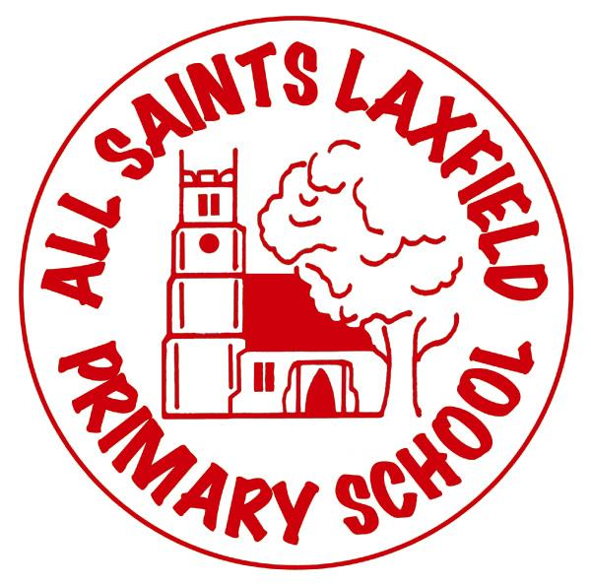
All Saints MFL Curriculum
A family. Uniquely made and loved by God

Intent
At All Saints, the intention of our MFL curriculum is to develop an interest in and thirst for learning other languages. Our current MFL taught is French, however we want to give our children as wide a range of opportunities and experiences as possible. We recognise the influence that Europe has on our lives and as the UK is becoming an increasingly multicultural society, we have a duty to provide our children with an understanding of other cultures and languages. We aim to introduce the learning of the French language and understanding of the culture in enjoyable and stimulating ways. We hope to embed the essential skills of speaking, listening, reading and writing.

Implementation Making MFL come alive.
All children in Key Stage 2 are taught in a weekly, discrete lesson. Key Stage 1 children are introduced to MFL by exploring languages informally when learning about other countries.
Our MFL curriculum has been designed to progressively develop skills in French. It ensures that children develop a bank of vocabulary around a range of topics, many of which are revisited and built upon year after year.
Teaching staff use a variety of techniques to encourage children to have an active engagement with MFL, including:
• Games – in order to develop vocabulary through repetition, reading, writing, speaking and listening skills.
• Role-play – these should relate to the situations the children may find themselves in the future.
• Action songs and rhymes – to develop phonetic skills, memory skills and to further vocabulary.
• High quality reading and writing materials.
• ICT programs and websites to develop communication skills.
• We try to make the lessons as entertaining and enjoyable as possible. We recognise that this approach serves to develop a positive attitude in the children to the learning of modern foreign languages. We use a model of listen and repeat when learning new vocabulary. This helps to ensure correct pronunciation is used.
• We build children’s confidence through praise for any contribution they make in the foreign language, however tentative.

Impact Assessment
Our MFL curriculum will ensure all pupils develop key language learning skills set out by the national curriculum, as well as a love of languages and learning about other cultures.
Teachers make assessments which are widely based on pupil interactions in class. Assessment is continuous and a simple record sheet is kept which uses orange, green and blue (as per our marking system) to show a child’s ability and understanding.

