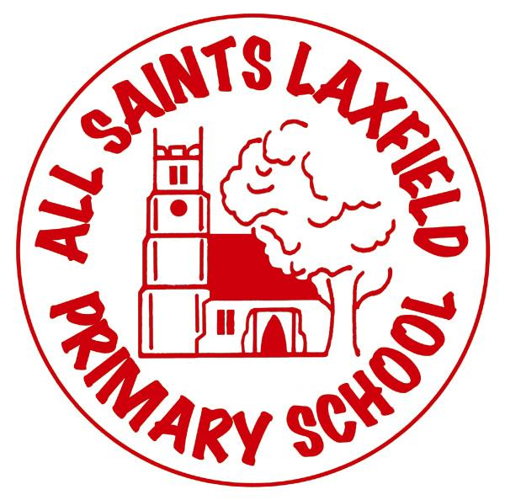
All Saints PSHE Curriculum
A family. Uniquely made and loved by God
Intent
At All Saints we believe that PSHE holds a unique place in the school curriculum. It is an opportunity to build skills, emotional literacy, positive attitudes towards mental health, self-esteem, resilience and confidence. This personal development needs to be taught explicitly as well as nurtured implicitly throughout the school day. As a subject, it is linked to RE, SMSC, PE and science but also develops life long skills of empathy and mindfulness within a context of British Values. It is a dynamic, relevant and ever-changing subject, which we want to impact our children’s behaviour, relationships and learning capacity.

Implementation Making PSHE come alive.
All Saints Trust schools have adopted the JIGSAW scheme of work. We began trialing it in Summer 2020 ready for to meet the new government guidance and outcomes. There are 6 themes/ units of work per year group: Being me in my world, Celebrating difference, Dreams and Goals, Healthy me, Relationships and Changing me ( including Sex Education). Each theme is based on specific PSHE learning, emotional literacy and social skills.

Impact Assessment
Each lesson has a formative assessment activity, which children and teachers can use to assess their progress. Children can record their ideas and progress in a journal. (We are currently trialing journals in some classes).

We see assessment in this subject as being evidenced through the excellent behaviour of our children, their attitudes towards others and their awareness of self.

