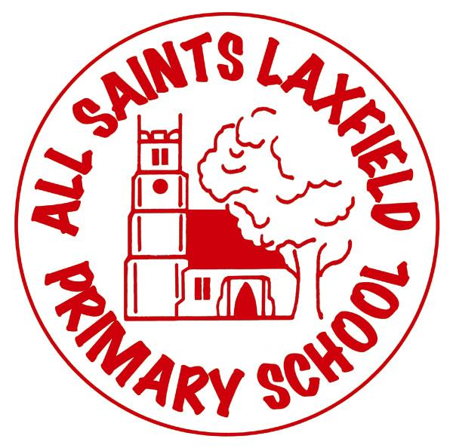
All Saints RE Curriculum
A family. Uniquely made and loved by God
Intent
At All Saints, we believe that RE provides children with the opportunity to learn about, as well as from, religion. It enables them to appreciate the principle religions in England and to gain an understanding of the beliefs, cultures and influences that shape people’s lives and behaviour. We believe this is the best way to prevent racism and combat prejudice. RE lessons provide opportunities for self-reflection and for children to think about their own identity within a rigorous curriculum. Both substantive and personal knowledge are key as children learn about concepts which are religion specific as well as those which are fundamental to many religions. The clear progression of our planning ensures a depth and breadth of curriculum which includes accurate representations of faith, people and artefacts. It also enables us to focus on the disciplinary aspect of RE so that children can understand how to learn about religion effectively.

Key concepts:
Beliefs, teaching and sources; Practices and ways of life; Forms of expression; Identity and belonging; Meaning, purpose and truth; Values and commitments.

Our locality

Our village has two churches: All Saints Church of England and Laxfield Baptist Church. We have services in these churches to mark Easter, Christmas and the end of the academic year. Children’s work and responses to our half termly value is displayed in both churches and parishioners offer responses to it. Members of the clergy lead Collective Worship every week and are regular visitors to school events.

Implementation Making RE come alive.

We follow the Suffolk RE scheme (The Emmanuel Project). Due to our ever-changing year group combinations, we supplement this scheme with units from Understanding Christianity as well as some written by the RE Co-ordinator.

Trips, visitors and the use of artefacts, drama, video and art, combine to make RE a subject that is vibrant, engaging and thought provoking. Wherever relevant, its links to history, geography, SMSC, PSHE and art are developed to enable children to fully understand its impact upon the world.
Children’s work, thoughts and ideas are recorded in a class scrapbook, which logs the ‘journey’ through the unit of work.

Impact Assessment
RE is assessed against statements which show each pupil’s outcomes as Working Towards, At Expected or Greater Depth. Teachers use a variety of approaches to make these end of unit assessments including both summative and formative assessment. These may include written work, art, drama and discussions.

