All Saints, Laxfield Primary School
2019 Calculation Policy

The following calculation policy has been devised to meet requirements of the National Curriculum 2014 for the teaching and learning of mathematics, and is also designed to give pupils a consistent and smooth progression of learning in calculations across the school. Please note that early learning in number and calculation in Reception follows the Development Matters EYFS document, and this calculation policy is designed to build on progressively from the content and methods established in the Early Years Foundation Stage.

Age stage expectations
The calculation policy is organised according to age stage expectations as set out in the National Curriculum 2014, however it is vital that pupils are taught according to the stage that they are currently working at, being moved onto the next level as soon as they are ready, or working at a lower stage until they are secure enough to move on.

Providing a context for calculation:
It is important that any type of calculation is given a real life context or problem solving approach to help build children’s understanding of the purpose of calculation, and to help them recognise when to use certain operations and methods when faced with problems. This must be a priority within calculation lessons.

National Curriculum Addition
Year One
The + and = signs and missing numbers
Children need to understand the concept of equality before using the ‘=’ sign. Calculations should be written either side of the equality sign so that the sign is not just interpreted as ‘the answer’.
Example
2 = 1+ 1
- + 3 = 4 + 1
- = 3
- + 2 + 2 = 4 + 2
Missing numbers need to be placed in all possible places.
- + 4 = = 3 + 4
3 + = 7 7 = + 4
+ 4 = 7 7 = 3 +

Use of prepared number lines and concrete objects
2

3

4

5

6

7

8

9

10

11

12

Children are encouraged to record by drawing jumps on prepared lines.
Year Two
The + and = signs and missing numbers
Continue using a range of equations (See Year 1) but with appropriate, larger numbers as specified in Year 2 grade level standards, i.e. extend to 14 + 5 = 10 + and 32 + + = 100 35 = 1 + + 5.

Partition into tens and ones and recombine
12 + 23 = 10 + 2 + 20 + 3
= 30 + 5
= 35
Partitioning the second number only
23 + 12 = 23 + 10 + 2
+10

+2

= 33 + 2
= 35 23 33 35

Example: Add 9 or 11 by adding 10 and adjusting by 1 35 + 9 = 44
Year Three
The + and = signs and missing numbers
Continue using a range of equations as in Year 1 and Year 2 but with appropriate larger numbers specified in the gradelevel standards.

Progression in mental calculations with larger numbers
Calculate HTU + U
Calculate HTU + TU
Calculate HTU + HTU
Progress from no crossing of boundaries to crossing of boundary.

Partition into tens and ones and recombine Develop from Year 2- partitioning both numbers and recombining.

Refine to partitioning the second number only:
36 + 53 = 53 + 30 + 6
+30

+6

= 83 + 6
= 89 ₅₃ ₈₃ ₈₉
Add a near multiple of 10 to a two-digit number Continue work from Year 2 but with appropriate numbers: 35 + 19 is the same as 35 + 20 – 1.

Formal methods of columnar addition to add numbers with up to three digits
285
+73
8
150
200
358

Extend to decimals in the context of money
£ 2.50 + £ 1.75
£ 2.50
+ £ 1.75
£ 4.25
1
The expanded method should be used if children experience persisting difficulties.

Year Four
The + and = signs and missing numbers
Continue using a range of equations as in Key Stage 1 and Year 3 but with appropriate numbers.
Partition into hundreds, tens and ones and recombine Either partition both numbers and recombine or partition the second number only e.g.
358 + 73 = 358 + 70 + 3
= 428 + 3
= 431

Add or subtract the nearest multiple of 10 or 100, then adjust
Continue as in Year 2, 3 and 4 but with appropriate numbers e.g. 458 + 79 = is the same as 458 + 80 - 1

Addition of numbers with at least four digits using formal method of columnar addition
358
+73
431
1 1
3587
+675
4262
1 1 1
The formal, efficient method of columnar addition will involve crossing of boundaries (at the tens, hundreds and/or thousands). Take a systematic approach to teaching this looking at crossing each boundary in turn before mixed practice.

Revert to expanded method if children experience difficulties.

Extend addition to decimals (same number of decimals places) and adding several numbers (with different numbers of digits).

National Curriculum Subtraction
Year One
The - and = signs and missing numbers
7 - 3 = ? ? = 7 - 3
7 - ? = 4 4 = ? - 3

Use of pictures, marks and concrete objects

Sam spent 4p. What was his change from 10p?

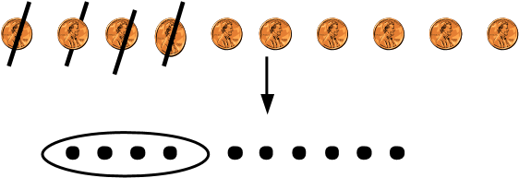

Number Lines
Example- Counting Back/Down
11 – 7
0 1 2 3 4 5 6 7 8 9 10 11 12

Example- Counting On/Up
The difference between 7 and 11

0 1 2 3 4 5 6 7 8 9 10 11 12
Children are encouraged to record by drawing jumps on prepared lines and constructing their own lines.

Year Two
The – and = signs and missing numbers
Continue using a range of equations (See Year 1) but with appropriate numbers in relation to Year 2 grade-level standards, i.e. extend to 14 + 5 = 20 - .

Find a small difference by counting up
42 – 39 = 3 + 1 + 2

39 40 42

Example: Subtract 9 or 11 & begin to add/subtract 19 or 21
35 – 9 = 26 ₊₁

-10
25

3
5

26

Use known number facts and place value to subtract
(Partition second number only) 37 – 12 = 37 – 10 – 2 = 27 – 2 = 25

Year Three
The - and = signs and missing numbers
Continue using a range of equations as in Year 1 and Year 2 but with appropriate larger numbers specified in the gradelevel standards.

Find a small difference by counting up
Continue from Year 2 but with appropriate numbers, e.g. 102 – 97 = 5

Subtract mentally a ‘near multiple of 10’ to or from a two-digit number, extending to three digit numbers
Continue as in Year 2 but with appropriate numbers e.g. 78 – 49 is the same as 78 – 50 + 1

Progression in mental calculations with larger numbers
Calculate HTU - U
Calculate HTU - T
Calculate HTU - H
Progress from no crossing of boundaries to crossing of boundary.

Formal methods of columnar subtraction to subtract numbers with up to three digits
See Appendix 1 examples in Year 5 and Year 6 section of this document.

*From Year 3 onwards, teachers need to keep in mind the methods specified in grade-level standards for end of Key Stage 2. Children should be developing their capacity to use formal written methods for all four number operations.

Year Four
The – and = signs and missing numbers
Continue using a range of equations as in Key Stage 1 and Year 3 but with appropriate numbers.

Differences
Find a difference by counting up, e.g. 8006 – 2993 = 5013. This can be modelled on an empty number line.

Use known number facts and place value to subtract decimals
6.1 – 0.4 = 5.7
5.7 6.0 6.1

-0. 3 -0 .1

Subtraction with at least four digits using formal method of columnar subtraction
For instance, 6467 – 2684 = 3783
Using expanded column subtraction where children experience difficulty with decomposition.

Extend subtraction to decimals (same number of decimals places) and adding several numbers (with different numbers of digits)

As specified in Year 3, teachers need to keep in mind the methods specified in grade-level standards for end of Key Stage 2. Children should be developing their capacity to use formal written methods for all four number operations.

National Curriculum Multiplication
Year One
Use of pictures and objects
There are 3 sweets in one bag.
How many sweets are there in 5 bags?

Count in multiples of one, two, five and ten Counting steps using bead string and on prepared number lines.

Counting in multiples using a range of objects, e.g. pairs of legs on animals; fingers in gloves etc.

Use of arrays

Counting in rows and columns
Two groups of three is six
Three groups of two is six

So 6 = 2 + 2 +2 or 6 = 3 + 3
Year Two
The x and = signs and missing numbers
7 x 2 = ? ? = 2 x 7
7 x? = 14 14 = ?x 7 ? x 2 = 14 14 = 2 x ?

Use materials, arrays, repeated addition
(including solving problems in context)

    4 x 2 or 4 + 4  
2 x 4

Or repeated addition

0 1 2 3 4 5 6 7 8
2 + 2 + 2 + 2
Year Three
The x and = signs and missing numbers
Continue using a range of equations as in Year 2 but with appropriate numbers in relation to grade-level standards.

TU x U
Use known facts x3, x4, x8 (Year 3 grade-level standards) and x2, x5 and x10 (Year 2 grade-level standards).
x 30 5  2 60 10 | x 30 2  3 90 6

At Year 3, children progress to using more formal written methods. In this case, the grid method drawing on knowledge of place value, multiplication facts and their ability to recombine partitioned numbers to derive an answer.

*From Year 3 onwards, teachers need to keep in mind the methods specified in grade-level standards for end of Key Stage 2. Children should be developing their capacity to use formal written methods for all four number operations.

Year Four
The x and = signs and missing numbers
Continue using a range of equations but with appropriate numbers for Year 4.

TU x U (See Year 3) and HTU x U (Introduced in Year 4 grade-level standards).
Partition
23 x 4 = 92

23 x 4 = (20 x 4) + (3 x 4)
= (80) + (12)
= 92

Use the grid method of multiplication
23 x 7 is approximately 20 x 10 = 200
x | 20 | 3
7 | 140 | 21

As specified in Year 3, teachers need to keep in mind the methods specified in grade-level standards for end of Key Stage 2. Children should be developing their capacity to use formal written methods for all four number operations.

NB: It is at the teacher’s discretion on whether they progress the year 4s onto the formal written method of short multiplication. This will depend on the ability of the class and the children.

National Curriculum Division
Year One
Use of pictures and objects or marks
12 children get into teams of 4 to play a game. How many teams are there?
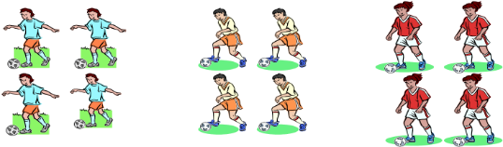
Sharing
6 sweets are shared between 2 people. How many do they have each?

Make use of practical activities involving sharing, e.g. distributing cards when playing a game, putting objects onto plates, into cups, hoops etc.

Year Two
The ÷ and = signs and missing numbers
6 ÷ 2 = ? ? = 6 ÷ 2
6 ÷ ? = 3 3 = 6 ÷ ?
? ÷ 2 = 3 3 = ? ÷ 2

Use materials, arrays, repeated addition
(including solving problems in context)
Use of sharing and grouping

Sharing
6 sweets are shared between 2 people.
How many do they have each?

Grouping
There are 6 sweets.
How many people can have 2 each?
(How many 2’s make
6?)

0 2 4 6
Find and name fractions of length, shape and sets of objects and quantities
Use of diagrams- count all equal parts to determine denominator. Link to division into equal groups/parts.
Year Three
MD3.2 The ÷ and = signs and missing numbers Continue using a range of equations as in Year 2 but with appropriate numbers in relation to grade-level standards.

MD3.2 TU ÷ U Grouping
How many 3s make 18? 0 3 6 9 12 15 18

MD3.2 & MD3.3 Remainders
16 ÷ 3 = 5 r1
Sharing – There are 16 sweets shared between 3, how many left over?
Grouping – How many 3s make 16, how many left over?
0 3 6 9 12 15 16

Children with secure knowledge of multiplication facts and subtraction may progress to ‘chunking’ where TU are divided by U.

*From Year 3 onwards, teachers need to keep in mind the methods specified in grade-level standards for end of Key Stage 2 (See Year 5 and Year 6 Calculation Policy Document). Children should be developing their capacity to use formal written methods for all four number operations.

Year Four
The ÷ and = signs and missing numbers
Continue using a range of equations but with appropriate numbers for Year 4.

MD4.3 Sharing and grouping 30 ÷ 6 can be modelled as:
Grouping – groups of 6 taken away and the number of groups counted e.g.
6 + 6 + 6 + 6 + 6
+
0 6 12 18 24 30

Sharing – sharing among 6, the number given to each person.

Remainders
Note three approaches below:
41 ÷ 4 = 10 r1 ₊₄₀
+1

10

groups

10
x
4

41 = (10 x 4) + 1
Towards the end of year 4 children will begin to develop short division to prepare them for the formal written methods in year 5 and year 6.

As specified in Year 3, teachers need to keep in mind the methods specified in grade-level standards for end of Key Stage 2 (See Year 5 and Year 6 Calculation Policy Document). Children should be developing their capacity to use formal written methods for all four number operations.

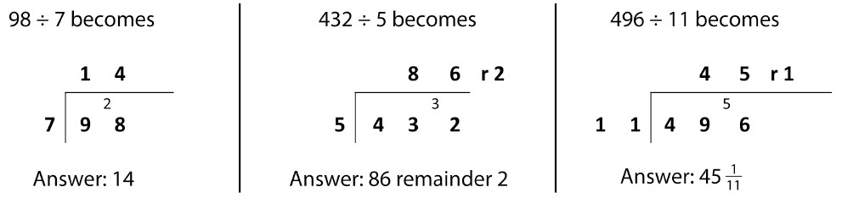

New Mathematics Calculation Policy: Year 5 and Year 6
The exemplification of formal methods here should be taken into account by all Key Stage 2 teachers so children are adequately prepared by Year 5 and into Year 6 to use the means of calculating specified in grade-level standards.
Addition & Subtraction
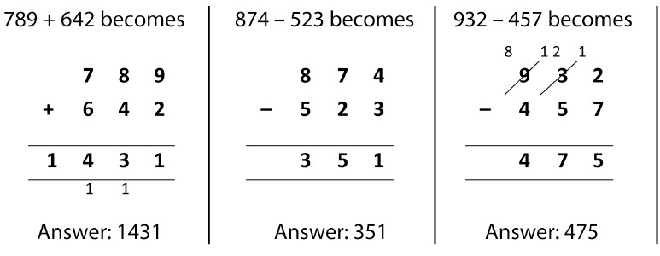
AS5.1
Columnar
Addition &
Subtraction
Multiplication & Division
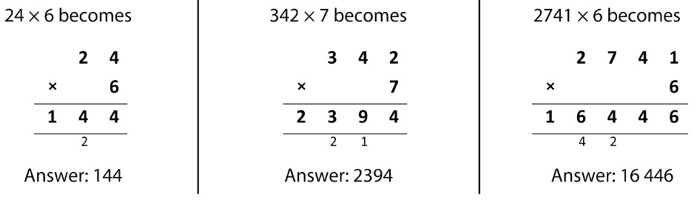
MD5.5 Short Multiplication
(DfE, 2013,
Appendix 1)

MD5.7 & ASMD6.2b
Short Division
(DfE, 2013, Appendix 1)

Long division will be at the teacher’s discretion. Children are able to do double digit division using the short method of division.
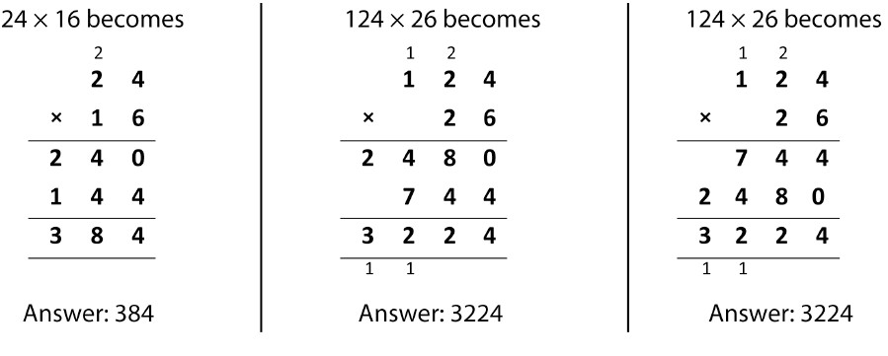
MD5.5 & ASMD6.1 Long
Multiplication
(DfE, 2013,
Appendix 1)

ASMD6.2a
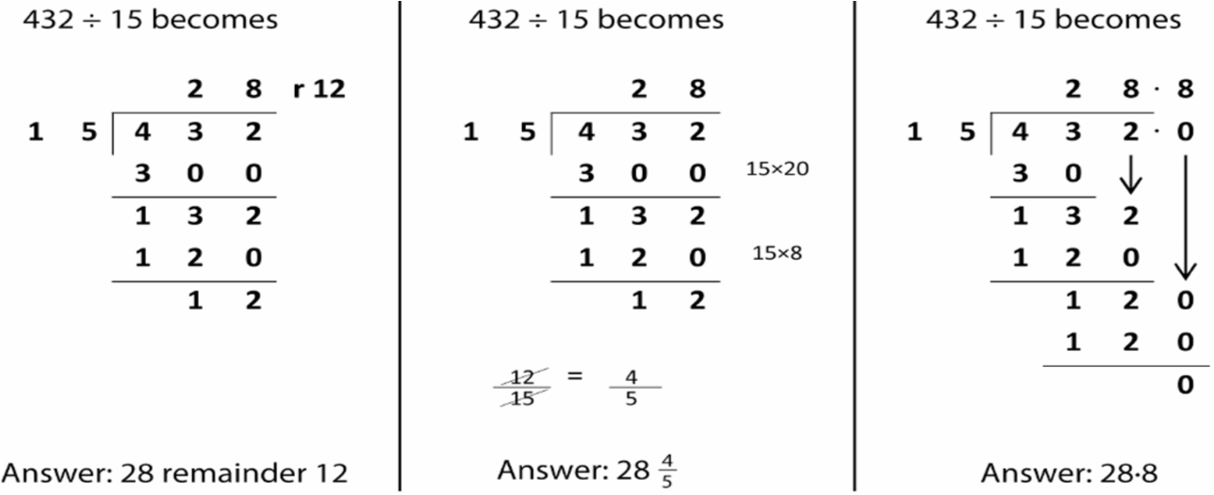
Long Division
(DfE, 2013, Appendix 1)

